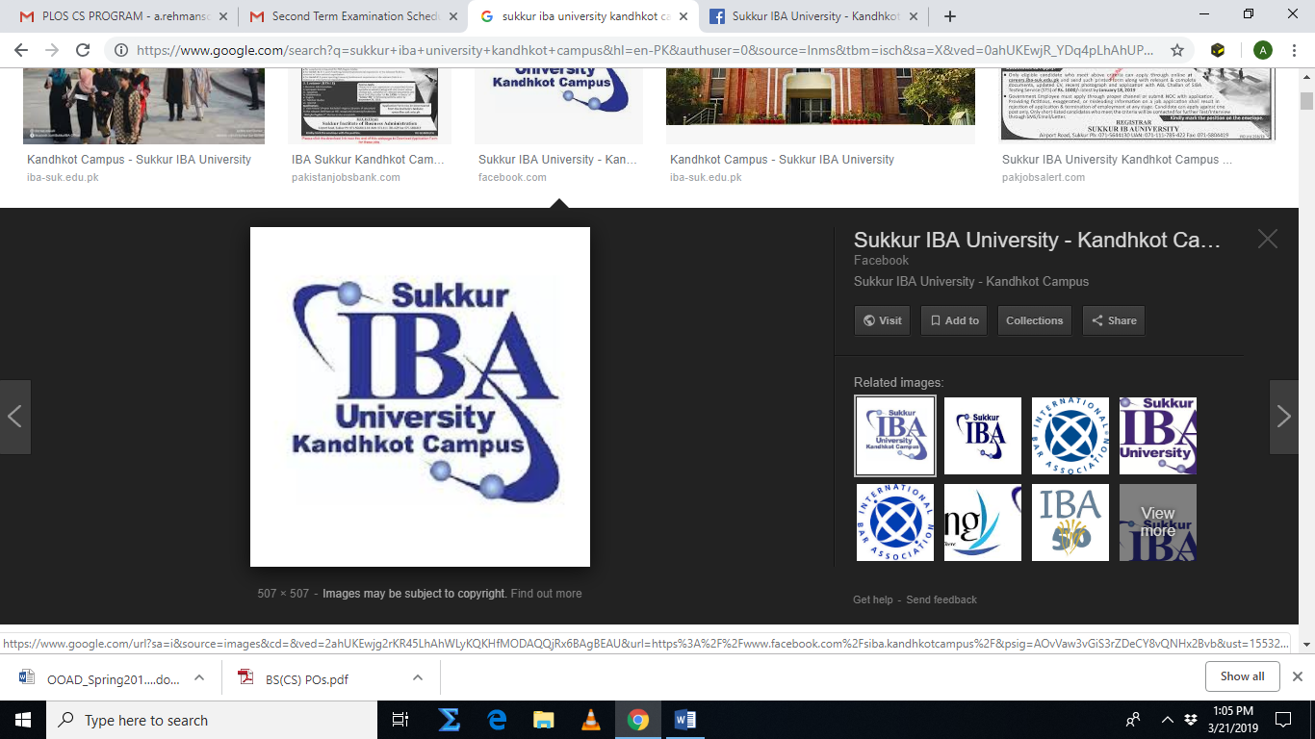

SUKKUR IBA UNIVERSITY
DEPARTMENT OF COMPUTER SCIENCE

ABET-2000 COURSEBINDER

MTS-112

MULTIVARIATE CALCULUS

PREPARED BY

ABDUL REHMAN SOOMRO

FALL 2025

FACULTY OF COMPUTTER SCIENCE
Multivariate Calculus (MTS-112)
Course Syllabus (ABET -2000 Format):
Course Outline

1. Course Identification and General Information

Class & Program: BS(CS)-III (4 years) | Semester: Fall 2025
Credit Hours: 04 (Theory) | Instructors: Mr. Abdul Rehman Soomro  Email: a.rehmansoomro@iba-suk.edu.pk  Office Location: Faculty room 02
Pre-requisite Course: Calculus | Counseling Hours: Monday, Wed & Thursday 3:30pm - 5:30pm

2. Schedule of Assessment Tasks for Students during the Semester

S.No: | Assessment Task (e.g. Presentation & discussion etc.) | Week Due | Proportion of Final Assessment/Marks
1 | 03 Quizzes | 4, 9 & 16 | 10(3+3+4)
2 | 04 Assignments | 7,9,13 & 17 | 10(2.5+2.5+2.5+2.5)
3 | 01 Mid-Term | Academic  Calendar | 30
4 | Final exam | Academic  Calendar | 50

- Course Description
This course takes calculus from the two dimensional world of single variable functions into the three dimensional world, and beyond, of multivariable functions. Students explore the following topics: Advanced techniques of integration, vector geometry, the analytic geometry of lines, calculus of curves in two or three dimensions, including arc length and curvature; calculus of scalar-valued functions of several variables, including the gradient, directional derivatives and the Chain Rule double integrals in rectangular triple integrals in rectangular, calculus of vector fields including divergence and curl.

- Course Contents

Session No. | Date / Week | Topic | Assignments/  Quizzes | Suggested Readings
1-2 | Week 01 | Review of Basic Integration Rules | Solving Exercise and Practice problems | Chapter 8
3-4 | Week 02 | Techniques of Integration, Integration by Parts and Trigonometric Integrals | Solving Exercise and Practice problems | Chapter 8
5-6 | Week 03 | Trigonometric Substitution and Integration of Rational Functions by Partial Fractions | Class Activity
7-8 | Week 04 | Introduction to Vectors and its application in Geometry of Space | Assignments 01 | Chapter 10
9-10 | Week 05 | The dot product and Cross Product of Vector in Space and their application | Solving Exercise and Practice problems | Chapter 12
11-12 | Week 06 | Function of Several Variables, Introduction to Multivariable functions, Limits of Function of Two and Three Variables | Solving Exercise and Practice problems | Chapter 12

13-14 | Week 7 | Partial Derivatives and The Chain Rule | Quiz -01 | Chapter  11,12,14,15
15-16 | Week 8 | Directional Derivatives and Gradient Vectors, | Solving Exercise and Practice problems
17-18 | Week 9 | Introduction to gradient, divergence and curl and their application | Class Activity  Assignments 02
19-20 | Week 10 | Mid Term-I
21-22 | Week 11 | Introduction to Multiple Integrals and Double Integrals | Solving Exercise and Practice problems
23-24 | Week 12 | Introduction to Multiple Integrals and Double Integral and their applications | Quiz -02
25-26 | Week 13 | Introduction to Triple Integrals | Assignments 03
27-28 | Week 14 | Introduction to Parametric Equation and Parameterizations of plane curves | Solving Exercise and Practice problems
29-30 | Week 15 | Introduction to Calculus with Parametric Curves(tangent), | Solving Exercise and Practice problems
31-32 | Week 16 | Application of parametric equations | Quiz -03
33-34 | Week 17 | Revision | Assignments 04
35-36 | Week 18 | Final Exam

- Text Book
- Thomas” Calculus (Global Edition) 13th Edition

- Reference Material
- Anton” Calculus Early Transcendental 10th Edition
- James Stewarts Multivariable Calculus 7th Edition

- Course Learning Objective

Course Learning Outcomes (CLOs)
1.Students will able to identify complex problem of derivative, integrals by using knowledge of mathematics
2. Students will be able to analyze complex application of mathematics in engineering and computer science.
3. Students will be able to apply appropriate method to solve of multivariate calculus problems and their applications in the optimization problem and two-dimensional regions.

CLO-SO Map
 | SO IDs
CLO ID | GA1 | GA2 | GA3 | GA4 | GA5 | GA6 | GA7 | GA8 | GA9 | GA10 | GA11
GA1 | 1 | 0 | 0 | 0 | 0 | 0 | 0 | 0 | 0 | 0 | 0
GA2 | 0 | 1 | 0 | 0 | 0 | 0 | 0 | 0 | 0 | 0 | 0
GA3 | 0 | 0 | 1 | 0 | 0 | 0 | 0 | 0 | 0 | 0 | 0

Approval
Prepared by | Mr. Abdul Rehman Soomro
Approved by | Not specified
Last Update | 09/ 08/2025

